VAIL RECREATION DISTRICT
2023 ADULT FLAG FOOTBALL LEAGUE RULES

GROUND RULES

- Games are at Homestake Peak Stadium on Sunday and, if necessary, Wednesday nights.
- No refunds will be granted after the start of league play.
- The Vail Recreation District (“VRD”), at its sole discretion, reserves the right to expel any individual or team for malicious or unsportsmanlike conduct, failure to observe rules, regulations and procedures. Fighting, taunting or offensive language of any kind will not be tolerated.

PLAYER ELIGIBILITY / ROSTERS

- Players must be at least 18 years of age by the first game of the season.
- A team roster is limited to a maximum of 20 players.
- Rosters must be turned in prior to the first game.
- Rosters must be filled out completely and signed by players, managers, and coaches.
- Players added to roster must sign the roster before the start of the game.
- Team coaches are responsible for ensuring to all players on the roster players.
- Rosters are frozen on October 1.

TEAM AND GAME ORGANIZATION

- Games are played by two teams of six (6) players.
- Each team must have at least five (5) players on the field.
- Failure to field at least 5 players result in a forfeit.
- A minimum of three (3) offensive players must be on the line of scrimmage at the snap.
- Defensive players rushing the quarterback on any play must line up at least 5 yards off the line of scrimmage prior to the snap (marked by a second beanbag).
- Defensive players lining up within 5 yards of the line of scrimmage can cross the line of scrimmage but not rush the quarterback.
- Rushes from the backfield must be initiated with a handoff to another offensive player.
- Game time marks forfeit time (NO grace period).
- Only the designated captain may talk to officials.
- Game duration consists of two (2) twenty (20) minute halves running clock.
- Play clock is twenty-five (25) seconds and kept on field by the official(s).
- Timeouts per half are two (2) one-minute (1) for each team.
- Running clock stops during the last two (2) minutes of the second half as follows:
  - Two-minute warning (30 seconds) – clock restarts on snap.
  - Incomplete pass – clock restarts on snap.
  - Out of bounds – clock restarts on snap.
  - Penalty – clock restarts on snap.
  - Touchdown – clock restarts on snap.
  - Extra point – clock restarts with next possession.
  - Timeout – clock restarts with snap.

TEAM AND GAME ORGANIZATION continued

  - Change of possession – clock restarts with snap.
  - Official’s timeout – clock restarts at official’s discretion.
- The running clock rules (#13 above) apply to each half for playoff games.
- Playing field will be 50 yards wide by 80 yards long with 10-yard end zones.
- First down zones are 20 yards (3 total); ball must cross the 20-yard zone line for a first down.
- Spotting ball for first down and touchdown – ball and one (1) foot of ballcarrier must cross the line (first down zone line or touchdown goal line); reaching over the line does not count.

MERCY RULE

- Team leads by at least 32 points after ten (10) minutes of the second half.

SCORING

- Touchdown – 6 points.
  - A touchdown is defined as a player’s front foot and ball breaking the plane of the goal line.
- Extra point attempts after a touchdown:
  - Running – 2 points
  - Passing – 1 point
- Safety – 2 points
  - Scoring team retains possession at the 20-yard line.
- Returned extra point attempt by defense – 2 points.

OVERTIME PERIOD(S)

- A coin toss will determine possession, according to “Definitions #2.
- Each possession is 1st and goal at the 10-yard line at the same end of the field.
- New series of 4 plays are awarded when a penalty typically results in an automatic 1st down.
- Possession alternates with each additional period.
- Overtime period continues until a winner is determined by final score.
- Each team gets one (1) timeout.

GAME EQUIPMENT

    - VRD will provide the official game ball.
    - Team must have similar color jerseys or wear same color penny provided by VRD.
    - Player flag must be always visible/available during play.
    - Athletic shoes or plastic cleats only.
    - The use of headgear of any nature, shoulder pads, body pads, shoes with removable cleats, or any unyielding or dangerous equipment is prohibited.
    - Stickum of any kind (on ball, body, gloves) is illegal.
    - A referee is considered part of the game and as result, the ball is considered “live” if it hits the official in the air.

PENALTIES

- See “Exhibit A” for detail.

DEFINITIONS

- Fumbles: play is dead when ball touches ground and marked where it hit the ground or player lost control.
- Coin Toss: Visiting teams makes call and winner has options:
  - Take possession.
  - Defend goal (teams change direction in 2nd half).
  - Defer – which gives them choice in 2nd half.
- No kickoffs: offensive team starts on 20-yard line.
- Punt: team must inform official of intent which cannot change.
- Punt return team: 2 players are allowed to field the ball; all other players must be idle until punted.
- Punt blocks: allowed if low kick (no leveraging players to block).
- Forward pass: one (1) per down.
- Lateral: unlimited.
- Eligible receivers: all players.
- Legal catch: one (1) foot on ground and inbounds.
- Flag removal: when clearly removed from player which is held above head by defender removing flag.
- Flag loss and tagging: player is down by tag if ball carrier loses flag during play.
- Tagging: by hand(s) anywhere between shoulders and feet.
- Spinning: avoiding de-flagging is not allowed.
- Jumping: avoiding de-flagging is not allowed.
- Rushing: defense must try to avoid contact with offense.
- Tackling: wrapping opponent to impede progress is not allowed.
- Charging: running through a player is not allowed.
- Clipping: hitting player in the back, below the waist is not allowed.
- Flag guarding: protecting against de-flagging is not allowed.
- Motion: more than one (1) offensive player at time of snap is not allowed.
- Stiff arm: to defend against an opponent is not allowed.
- Hurdling: attempt to jump over an upright opponent is not allowed.
- Stance: three (3) or four (4) point are not allowed.
- Defensive pass interference: contact by a defensive player that inhibits the offensive player to fair access to the ball.
- Flag use: worn as intended without alterations.

UNSPORTSMANLIKE PENALTIES AND CONDUCT

- See “Exhibit A and B” for details.

EXHIBIT A

SUMMARY OF PENALTIES

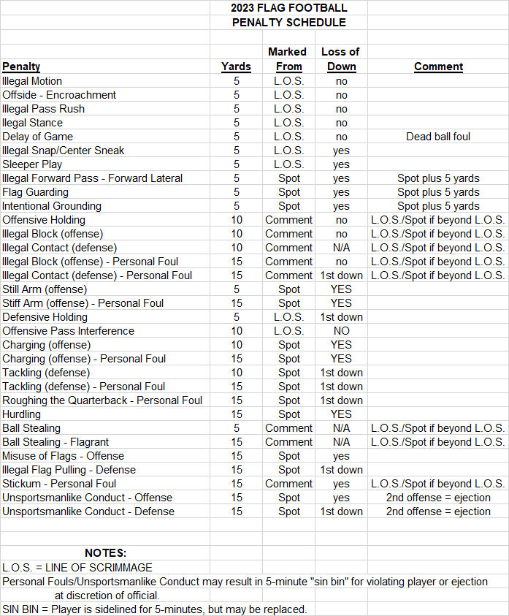

EXHIBIT B

CODE OF CONDUCT

THE VRD HAS TAKEN THE POLICY OF PROSECUTING ANY PLAYER, COACH OR SPECTATOR THAT VIOLATES ANY TOWN OF VAIL MUNICIPAL ORDINANCE SERIOUSLY.

1. No player shall at any time lay a hand upon, push, shove, or threaten to strike or verbally threaten any referee, official, supervisor or spectator.
Ruling: The offending player will be suspended from all VRD sports programs/activities for one (1) full year.
2. Any additional player(s) involved in a physical altercation with another player, coach, supervisors or spectator will:
a. Be ejected from the game.
b. Receive a minimum of three (3) game suspensions.
c. Be placed on “probation”.
3. Taunting, offensive language or unsportsmanlike behavior towards an official, supervisor, or staff member will result in the below listed items in the following order:
a. Ejection
b. Minimum of 1 game suspension
c. Probation
4. Officials and supervisors are empowered to warn, eject, and recommend suspensions for players and/or coaches for any misconduct or violation of rules.
5. Any player ejected from the game must leave the field, sidelines, and spectator area immediately. Failure to leave can result in the offending team’s forfeit.
6. If a game gets out of hand, the referees, field supervisor, or any VRD official has the authority to call the game, resulting in a forfeit to the offending team.
7. All suspensions carry with them automatic probationary periods. Once a player(s), coach(s) and/or team(s) have been placed on probation, their conduct will be evaluated throughout the remainder of the season. Further conduct violations will result in a minimum 2-game suspension extending through the remainder of the season.
8. Team captains are responsible for the conduct of their players and spectators before, during, and after the game.
9. Intoxication is an unacceptable and dangerous state of mind in which to play a game. No player will be permitted to play if acting in an intoxicated manner or if, in the referee’s or VRD official’s discretion, he seems intoxicated. Penalty – offending player is ejected from the current game and is suspended for the next league game.

